**Project Planning Phase**

**Project Planning (Product Backlog, Sprint Planning, Stories, Story points)**

| Date | 13 / 04 / 2025 |
| --- | --- |
| Team ID | 145269 |
| Project Name | Flight Finder |
| Maximum Marks | 5 Marks |

| **Sprint** | **Functional Requirement (Epic)** | **User Story Number** | **User Story / Task** | **Story Points** | **Priority** | **Team Members** |
| --- | --- | --- | --- | --- | --- | --- |
| Sprint-1 | Registration | USN-1 | As a user, I can register for the platform using email and password. | 2 | High | Team Member 1 |
| Sprint-1 | Registration | USN-2 | As a user, I will receive a confirmation email upon successful registration. | 1 | High | Team Member 2 |
| Sprint-1 | Login | USN-3 | As a user, I can log in using email and password. | 1 | High | Team Member 1 |
| Sprint-1 | Flight Search | USN-4 | As a user, I can search flights using criteria like date, destination, and passengers. | 3 | High | Team Member 3 |
| Sprint-1 | Flight Booking UI | USN-5 | As a user, I can view and select flights based on search filters. | 2 | Medium | Team Member 3 |
| Sprint-1 | Design | USN-6 | Design UI for search and booking pages. | 3 | Medium | Team Member 4 |
| Sprint-1 | Authentication | USN-7 | Implement JWT-based authentication for users. | 2 | High | Team Member 1 |
| Sprint-1 | Admin Login | USN-8 | As an admin, I can log in with special credentials to manage system operations. | 2 | Medium | Team Member 2 |
| Sprint-1 | Dashboard | USN-9 | As a user, I can view a dashboard summarizing my bookings and notifications. | 3 | Medium | Team Member 4 |
|  |  |  | Total Story Points: 19 |  |  |  |

**Project Tracker, Velocity & Burndown Chart (4 Marks)**

| **Sprint** | **Total Story Points** | **Duration** | **Sprint Start Date** | **Sprint End Date (Planned)** | **Story Points Completed** | **Sprint Release Date (Actual)** |
| --- | --- | --- | --- | --- | --- | --- |
| Sprint-1 | 19 | 14 Days | 18 Feb 2025 | 03 Mar 2025 | 18 | 03 Mar 2025 |
| Sprint-2 | 22 | 14 Days | 04 Mar 2025 | 17 Mar 2025 | 20 | 17 Mar 2025 |
| Sprint-3 | 22 | 14 Days | 18 Mar 2025 | 31 Mar 2025 | 21 | 31 Mar 2025 |
| Sprint-4 | 22 | 14 Days | 01 Apr 2025 | 13 Apr 2025 | 22 | 13 Apr 2025 |

**Velocity Calculation:**

Average Velocity = (18 + 20 + 21 + 22) / 4 = 20.25 Story Points per Sprint

**Sprint-1 Burndown Chart Data:**

| **Day** | **Planned Remaining Points** | **Actual Remaining Points** |
| --- | --- | --- |
| Day 1 | 19 | 19 |
| Day 2 | 17.57 | 18 |
| Day 3 | 16.14 | 16 |
| Day 4 | 14.71 | 15 |
| Day 5 | 13.29 | 13 |
| Day 6 | 11.86 | 12 |
| Day 7 | 10.43 | 11 |
| Day 8 | 9.00 | 9 |
| Day 9 | 7.57 | 8 |
| Day 10 | 6.14 | 6 |
| Day 11 | 4.71 | 5 |
| Day 12 | 3.29 | 3 |
| Day 13 | 1.86 | 1 |
| Day 14 | 0 | 0 |

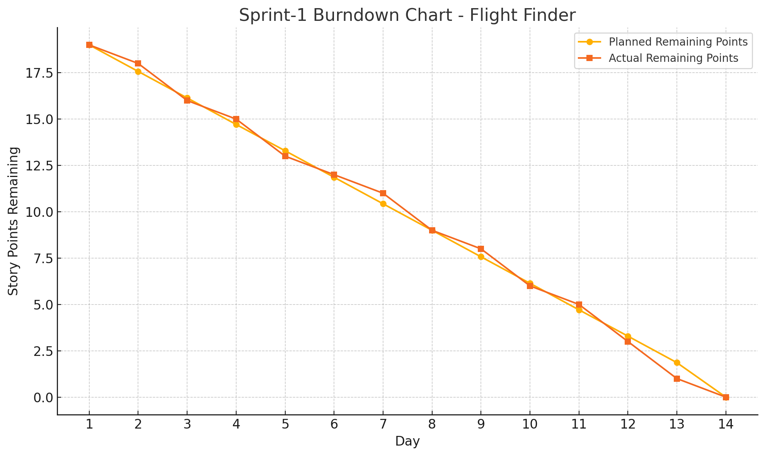

**Reference:**

**https://www.atlassian.com/agile/project-management**

**https://www.atlassian.com/agile/tutorials/how-to-do-scrum-with-jira-software**

**https://www.atlassian.com/agile/tutorials/epics**

**https://www.atlassian.com/agile/tutorials/sprints**

**https://www.atlassian.com/agile/project-management/estimation**

**https://www.atlassian.com/agile/tutorials/burndown-charts**